How to Create Mulitple website in magento 2

Step 1 : Create a host :

Open Terminal and execute following command

root@harsh:~# cd /etc
root@harsh:/etc# gedit hosts

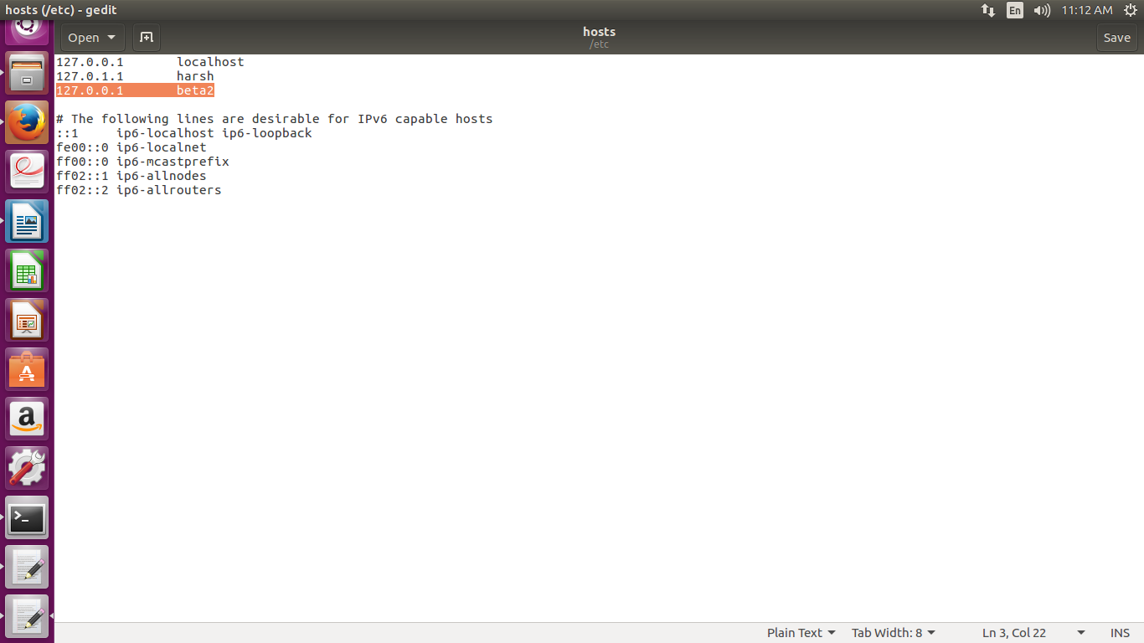
created a host named beta2 on 127.0.0.1

Step 2 : Create A website with the name of amazon.

Go to Store/Setting/Allstores

Than click on create Website.

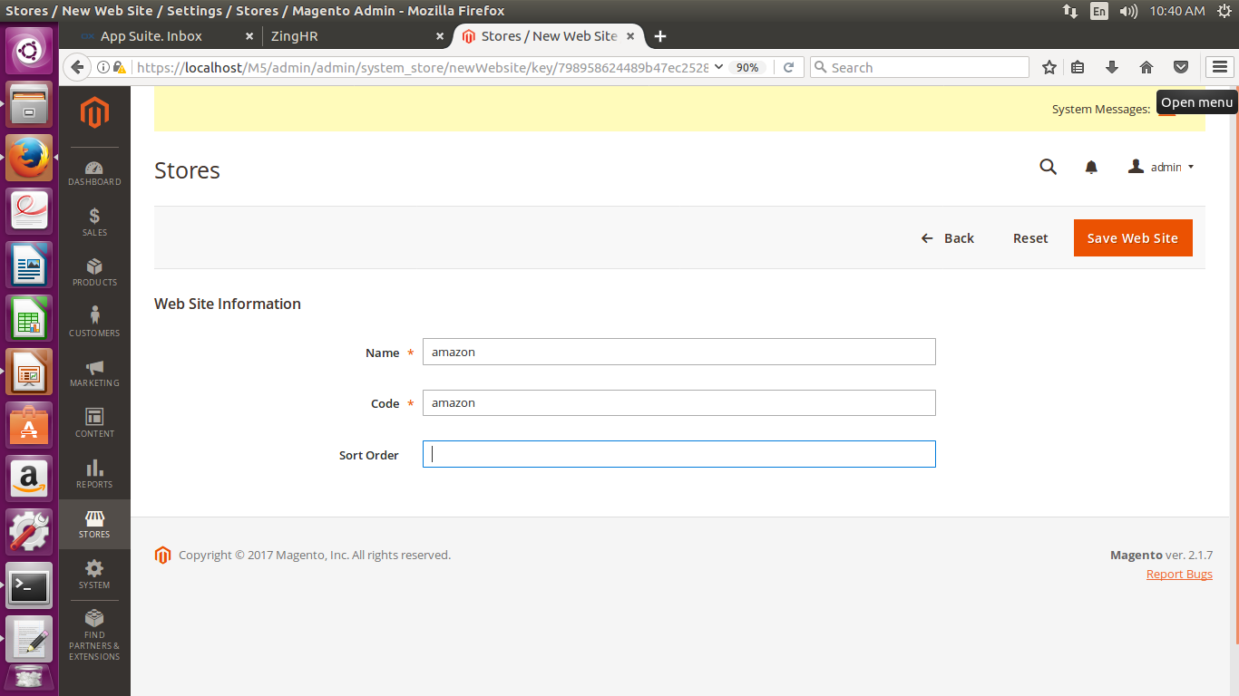
Create a website with the name of amazon and must remember the code of website it is also amazon

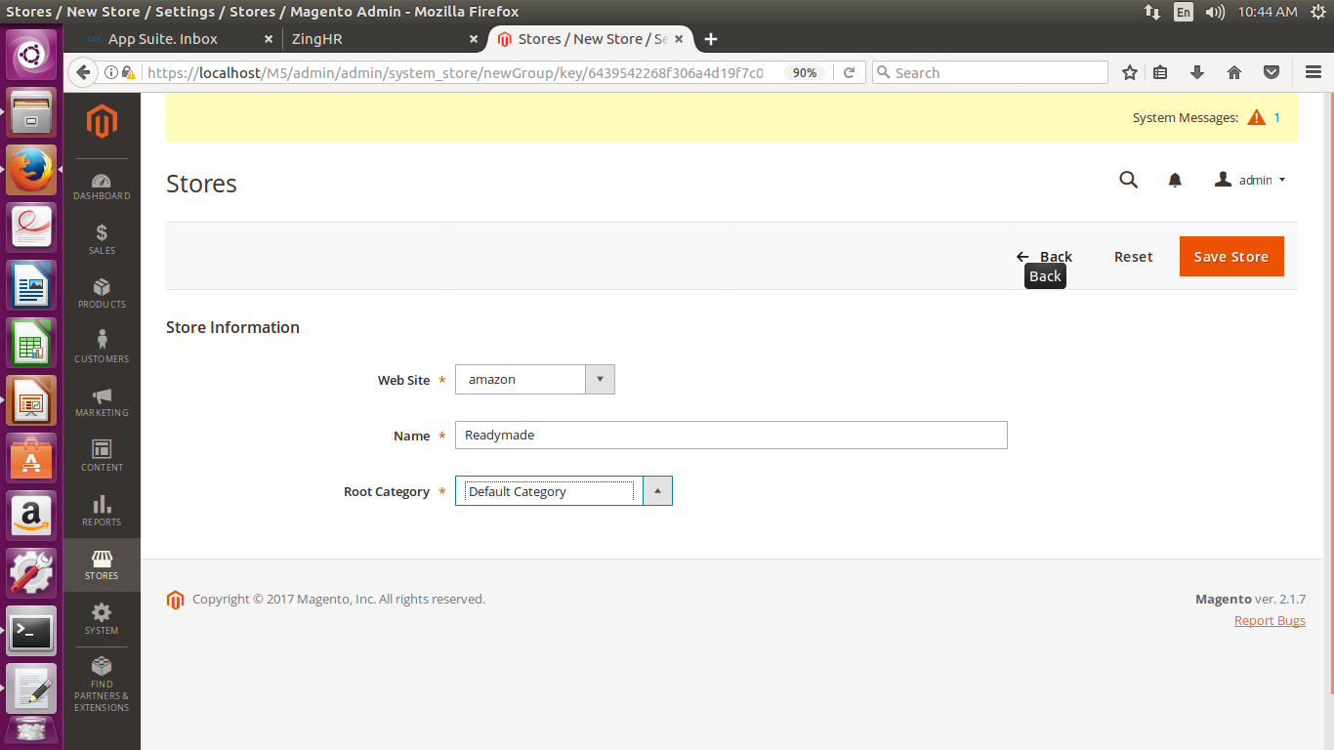
Now Create A store

now select website as Amazon than give store name Readymade and RootCategory will be Default category or other category if u had created.

Now Create Store view.

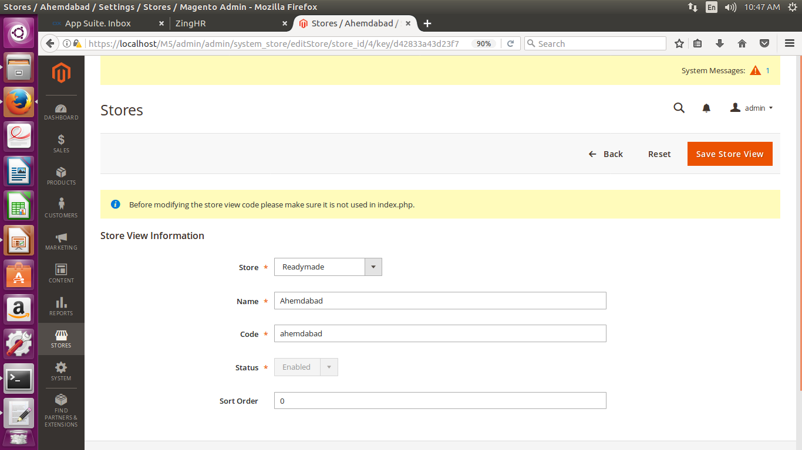

Create a store view named Ahemdabad

select store Readymade
name ahemdabad
code ahemdabad
status enable

step 3

afte creating website stores u have to base url for a particular site like amazon. We have to give path info in which we are going to run in url for this website.

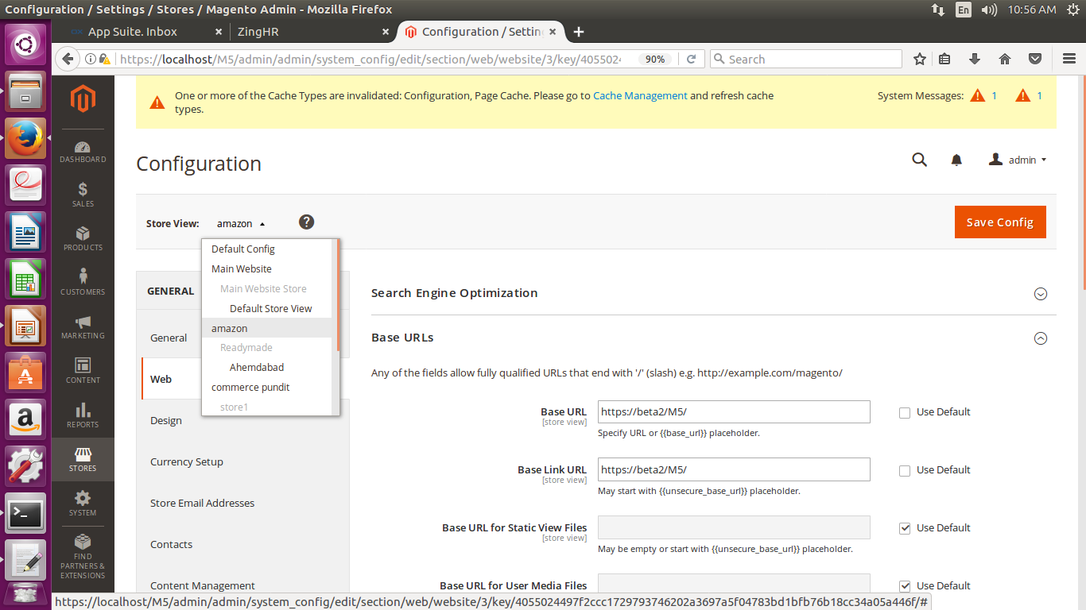

* Goto store/setting/configuration
* General/Web

* than select website from upper right corner from store
view we select amazon.
* now change base urls

Base Url: https://beta2/M5/
Base Link Url:https://beta2/M5/

* now change base urls (secure)

Secure Base Url: https://beta2/M5/
Secure Base Link Url:https://beta2/M5/
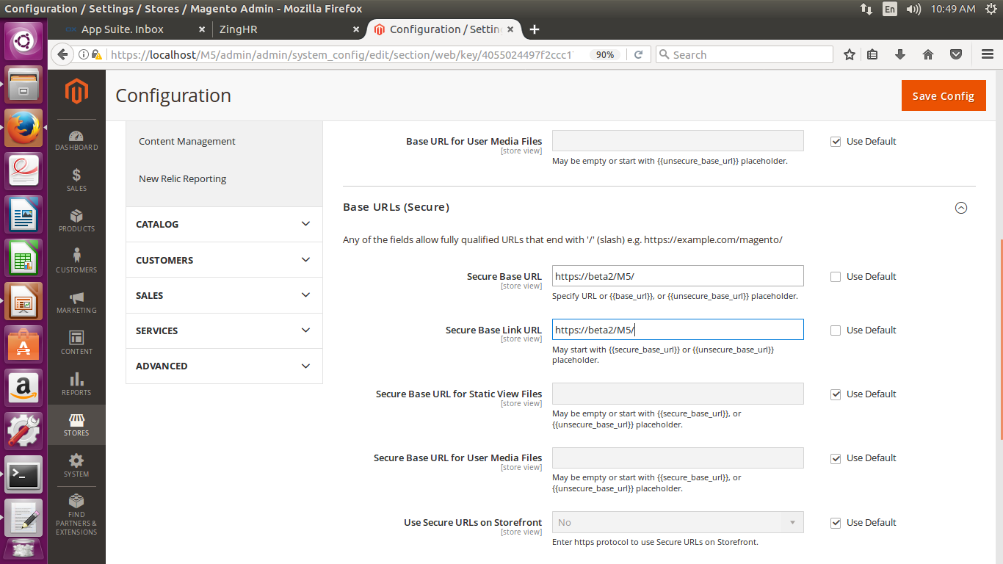

Now Save Config.

Step 4 now do changes in index.php given below in images

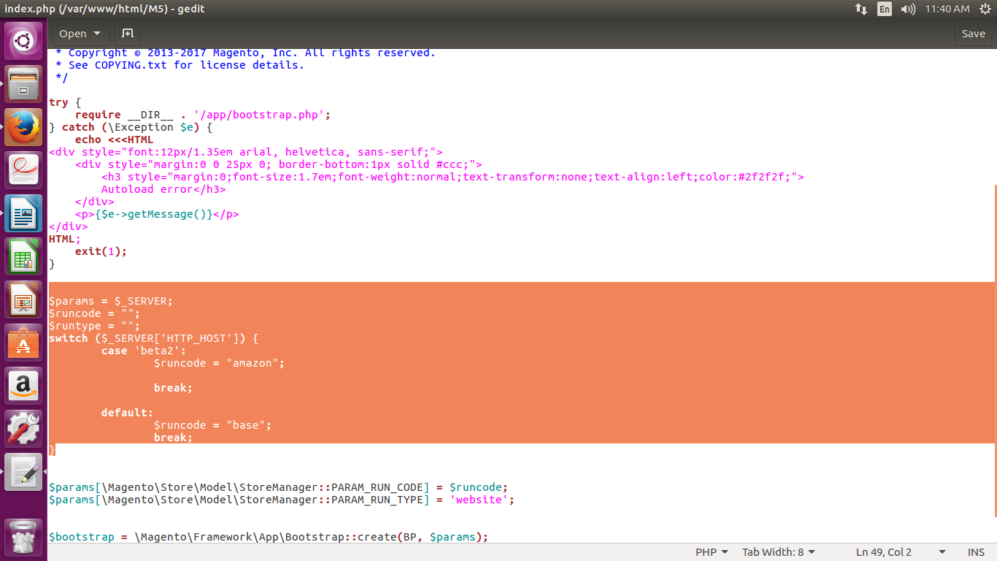
step 5 : now restart apache2.
And run website Than do reindexing and clean cache.

https://beta2/<your project name>/

ex : https://beta2/M5/
ex : https://beta2/magento2/

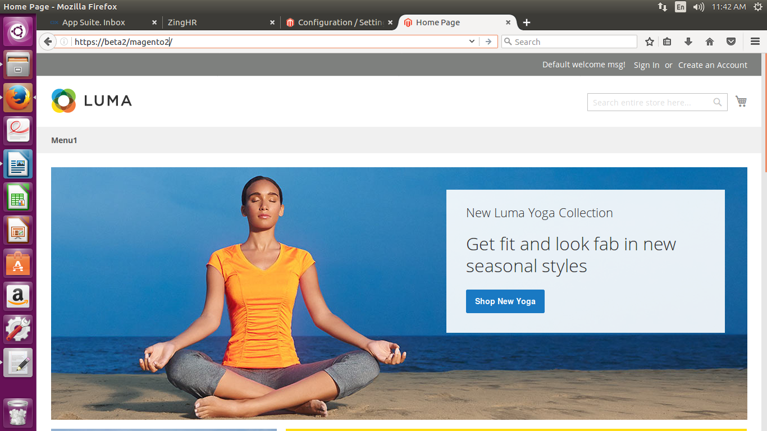
finish

